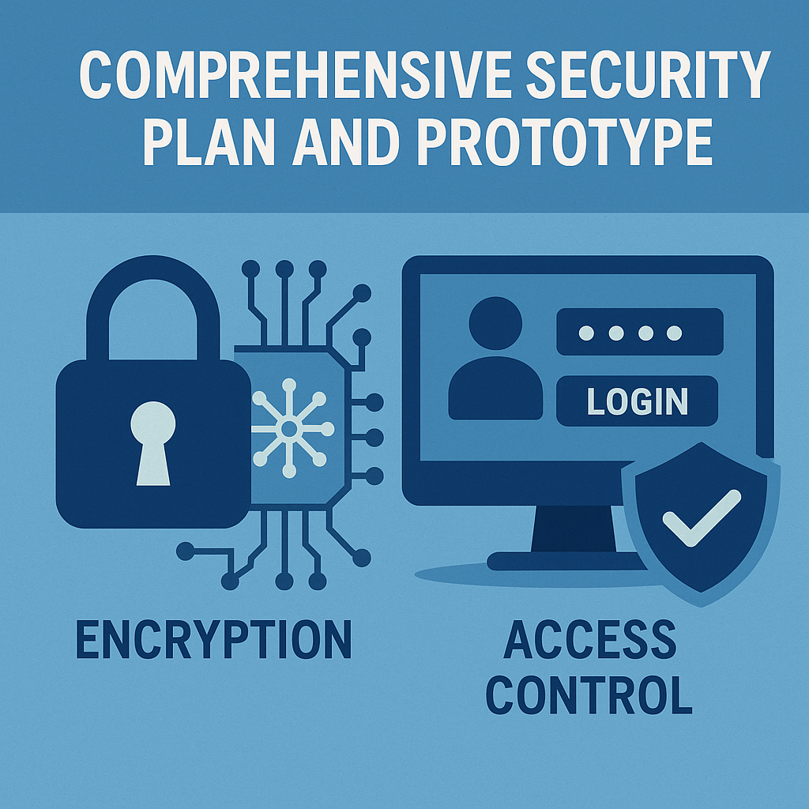

Danny LeBlond
CSC4022X00 Secure Software Engineering
Professor: Diane Rhodes
Red Rocks Community College
September 25th, 2025
In my e-commerce app I will protect customer data by using Advanced Encryption Standard together with Galois/Counter Mode. Chapter 5 of my textbook explains that Advanced Encryption Standard is the modern standard for block ciphers. It uses strong keys and replaces older systems like Data Encryption Standard (Anderson, 2020, p. 169). Also, the book points out that Galois/Counter Mode is just a way to use Advanced Encryption Standard that hides the info and also checks if anything got changed (Anderson, 2020, p. 180).
Advanced Encryption Standard works by taking normal text and mixing it up into unreadable stuff, and that's what we call ciphertext. In counter mode the process starts with a random number which is called an initialization vector (Anderson, 2020, pp. 178–179). Advanced Encryption Standard turns this into a stream of secret bits called a keystream which is then combined with the original data using a method that flips the data bits to create the ciphertext. This makes the data look random and unreadable. This way is fast and works well on modern computers (Anderson, 2020, pp. 178–179). But counter mode itself has problems. If the same initialization vector is ever used more than once the keystream will repeat and attackers can find patterns to learn things they shouldn't know. Also counter mode does not check for changes so attackers could try to alter messages without being caught (Anderson, 2020, pp. 178–179). To fix these problems the book says I can add Galois/Counter Mode. Galois/Counter Mode adds a special tag which is a short string of bits added from both the encrypted data and the secret key. It works kind of like a digital receipt that proves the data has not been changed. The tag is created during encryption and is checked again when the data is read. If the tag and the data do not match it means the information was changed or corrupted so the system will refuse to use it. When the system reads the data it checks the tag. If even one bit of data was changed the tag will not match, and the system rejects it (Anderson, 2020, p. 180). This gives both secrecy because the data is hidden, and integrity, because tampering can be spotted.
The book also points out that the main goal of cryptography is semantic security. This means attackers should not be able to figure out anything useful about the data or the keys (Anderson, 2020, p. 163). Advanced Encryption Standard in Galois/Counter Mode makes this true by keeping things like names, addresses, and payment data safe. Even if a hacker steals the database all they will see is random scrambled text. The tag makes sure they cannot secretly change that text without being noticed.
I will also use access control to control what different people can do in the system. Chapter 6 of my textbook explains that access control is about restricting access to resources based on roles, permissions, and policies (Anderson, 2020, pp. 209–210). Role-Based Access Control is one of the main models described, and it assigns permissions to roles instead of individual users. This makes it easier to manage security because users only gain access through the roles they are given (Anderson, 2020, pp. 209–210).
For my design I will use two roles. The first role is Customer. They are allowed to log in, and view their own orders and account details. The second role is Administrator. Administrators can view all customer accounts, update products, and also have the ability to deactivate accounts if they need to. These permissions match what Chapter 6 describes about Role-Based Access Control—permissions are grouped by roles, and each user is then assigned the role that matches their responsibilities (Anderson, 2020, pp. 205–206).
I will also use the secure design rule called least privilege. The OWASP Secure Coding Practices Quick Reference Guide says this means each user should only have the smallest amount of power needed to do their job (OWASP Foundation, 2021). This lowers the risk if an account is misused. For example customers can only change their own accounts, and administrators can manage the store but should not use their powerful accounts for normal shopping. The OWASP guide also warns not to give database accounts too much power. The database account will only be able to read and write to certain tables not delete tables or see all customer records. This helps stop attacks like SQL injection from doing real damage.
My prototype (in Python) uses Advanced Encryption Standard in Galois/Counter Mode with a 256-bit key to keep private data, like a customer’s address, safe. Advanced Encryption Standard in Galois/Counter Mode scrambles the data so it looks random, and it also makes a tag that checks if the data has been changed. If someone tries to change the ciphertext it will not get accepted. Passwords are not stored in plain text. The program uses PBKDF2-HMAC-SHA256 with a random salt for each password. The program also has two roles: customer and administrator. Customers can log in and see only their own address that they will be able to read. Administrators can make new users and list accounts, but they only see scrambled addresses.
In the end using cryptography, Role-Based Access Control, and least privilege all work together to keep the system safe. Each one helps on its own but when put together they block more problems. Encryption keeps the data private, Role-Based Access Control makes sure only the right people can do certain things, and least privilege means if something bad happens the damage is smaller.

References
Anderson, R. (2020). Security engineering: A guide to building dependable distributed systems (3rd ed.). Wiley.
OWASP Foundation. (2021). OWASP secure coding practices quick reference guide. OWASP Foundation. https://owasp.org

